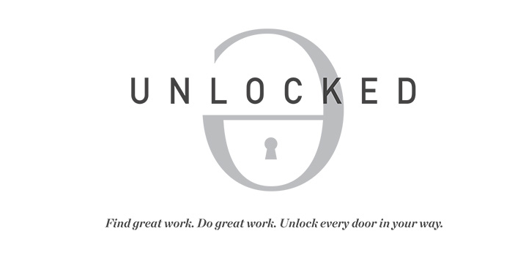

Resume Prep Kit

Dear :

You deserve a job that does more than just “pay the bills.”

You deserve to feel happy, energized and inspired by your boss and your co-workers.

You deserve a job that feels meaningful + personally satisfying.

One that allows you to make a contribution, while building the life that you want.

Having a stellar resume isn’t the ONLY thing you need to find work that you love.

But it’s an awfully big part.

So, let’s get started!

This Resume Prep Kit will kick off our work together.

Please return your completed Prep Kit — and a copy of your current resume — as soon as you can. Don’t forget to choose the best date for our phone call, at the end of the Kit. My email is: elfondiler@gmail.com

Here we go!

…

Full name:

Phone:

Email:

Mailing address:

Website / blog (if you have one):

Facebook:

Twitter:

LinkedIn:

Got any other social media profiles? List them here.

Have you written any articles … produced a video … hosted a podcast … or created any other forms of content that are available online? Paste a couple of links here. Share your very best work — the pieces you’re especially proud of.

What’s your ultimate dream job? (Don’t worry if you’re “qualified” or if it’s “realistic.” Think futuristically.)

What’s a more attainable version of that “dream job” that you’re qualified to apply for right now?

Fill in the blanks:

“When I see _____________ happening in the world, it breaks my heart. I know we can do better, and I’d love to be part of the solution.”

“I get really inspired by _____________, and I’d love to be a source of that kind of inspiration to others.”

“Some of my favorite brands / companies are _____________, _____________ and _____________, and I admire them because _____________.”

“One thing I’m really proud of — that I don’t talk about often — is _____________.”

“One thing that people often praise me / thank me for is _____________, which is weird because it comes so easily to me!”

“For me, work isn’t just about _____________. It’s also an opportunity to _____________.”
Make a list of the top 5 most impressive things you’ve done, to date — in any area of your life.

Be as specific as possible. (Think: “I wrote over 90 articles for my school newspaper, including one that received over 1,000 views on our school blog.” Not: “I wrote for my school newspaper.”)

1.

2.

3.

4.

5.

In addition to working on your resume, would you also like help …

(Type YES next to the items that you need.)

: Editing your cover letter.
: Prepping for a networking event.
: Prepping for your next job interview.
: Writing an email to a potential mentor.
: Something else? (Describe it, here.)

Is there anything else I should know about you?

Last but not least: please choose a date + time for our phone call.

Give me three options:

Great work!

Once again: please send this completed Prep Kit — and a copy of your current resume — to [email]. Once I receive it, I’ll send you an email to confirm our phone date … and away we go!

Ellen

Ellen Fondiler
Career Strategist for Millennials + Emerging Entrepreneurs|
Creator of UNLOCKED and The Countdown

